Word Recognition
Lo Chiung-yu, the author of Chinese Characters for Beginners stated the construction of Chinese characters can be categorized as follows: Pictographs, ideographs, Logical Aggregates and Determinative Phonetics. Pictographs were the primitive scripts that originated from pictures. Ideographs used symbols like lines or dots to indicated abstract ideas that pictographs could not convey. As rapid civilization took place, pictographs and ideographs were no longer adequate for expressing new abstract ideas. To fill the need, logical aggregates were invented. Then the determinative phonetics were developed to create new characters by combining a determinative element and phonetic elements. With this innovation, the Chinese writing system became complete.
So try to teach or to learn the Chinese characters. There it’s a set of alphabets like many Latin based the languages. You learn the alphabets then build the words from the alphabets. Each Chinese character is a picture. So the learners require good memories. However, just to memorize a bunch of words without contact clues would be painful or useless.
Here we provide a group of easy stroke characters to begin with. The learner starts recognize the simple word-pictures and understands the meanings, then gradually built from there. Quickly the learner will memorize 100 to 500 hundreds characters. Like many other languages, Chinese will become easier and much more interesting for the learners.
So the 100 characters will be introduced are based on the first three categories: pictographs, ideographs, and logical aggregates.
Group 1 There are 35 recognition words to start out with

1. 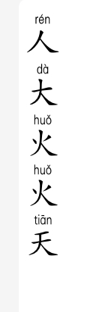 people，person（大big）（火 fire）
人人everybody
2. big（太too）（天sky，day）
大人 grown up, adult
3. fire
大火 big fire
4. 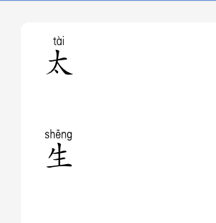 too
太大 too big, 太太Mrs. Madan
6. sky, day
天天 every day, each day
7.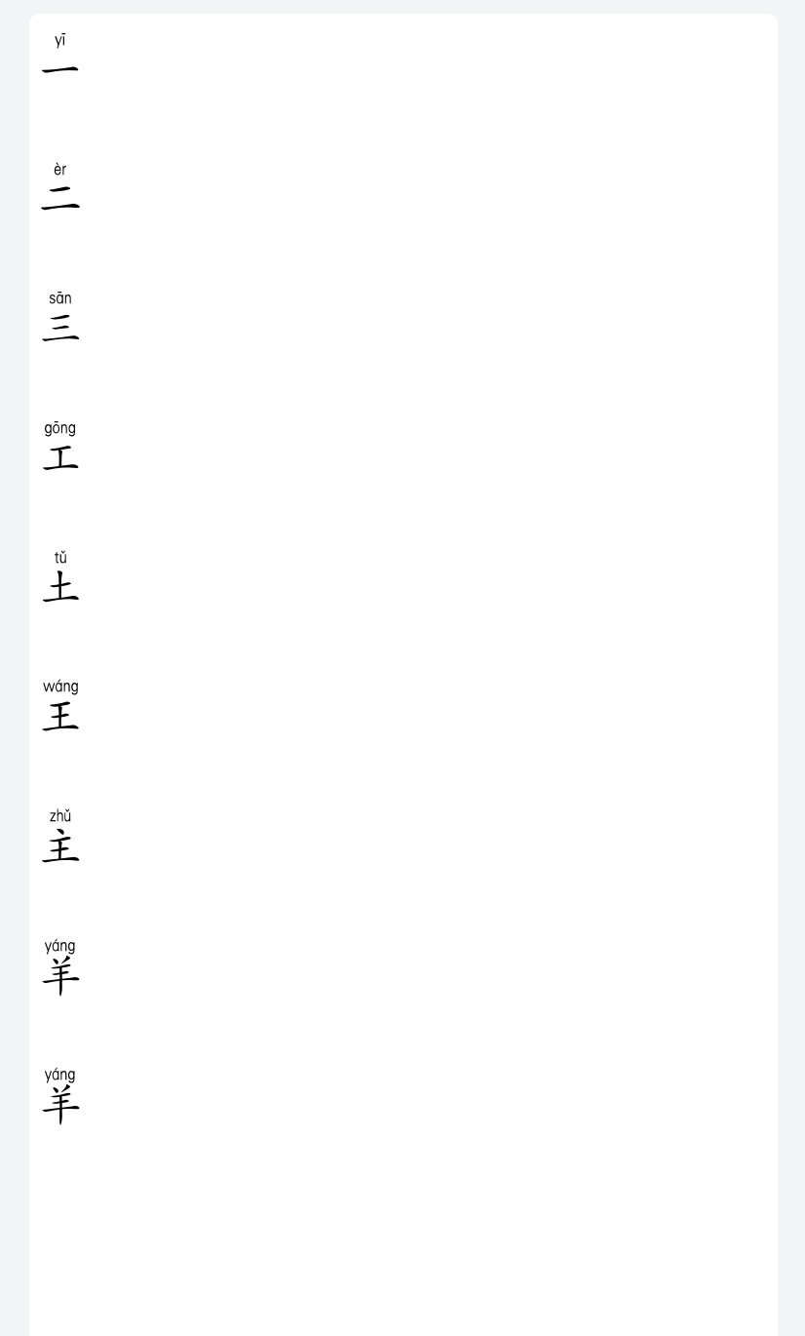one (二 two) (三three)
一天one day ，一人 one person
8. two（工 work）（土 earth, mud）
9. three（王 king）
三天 three days，三人 three people
10.Work
工人 worker，天天上工working everyday
11.earth
土人 clay figure, native
12. king （主 main）（羊 goat, lamb）（生to be born）
大王 big king, 天王 emperor
13. main
主人 master
14. goat, lamb
大羊big goat
15. to be born, student

16. 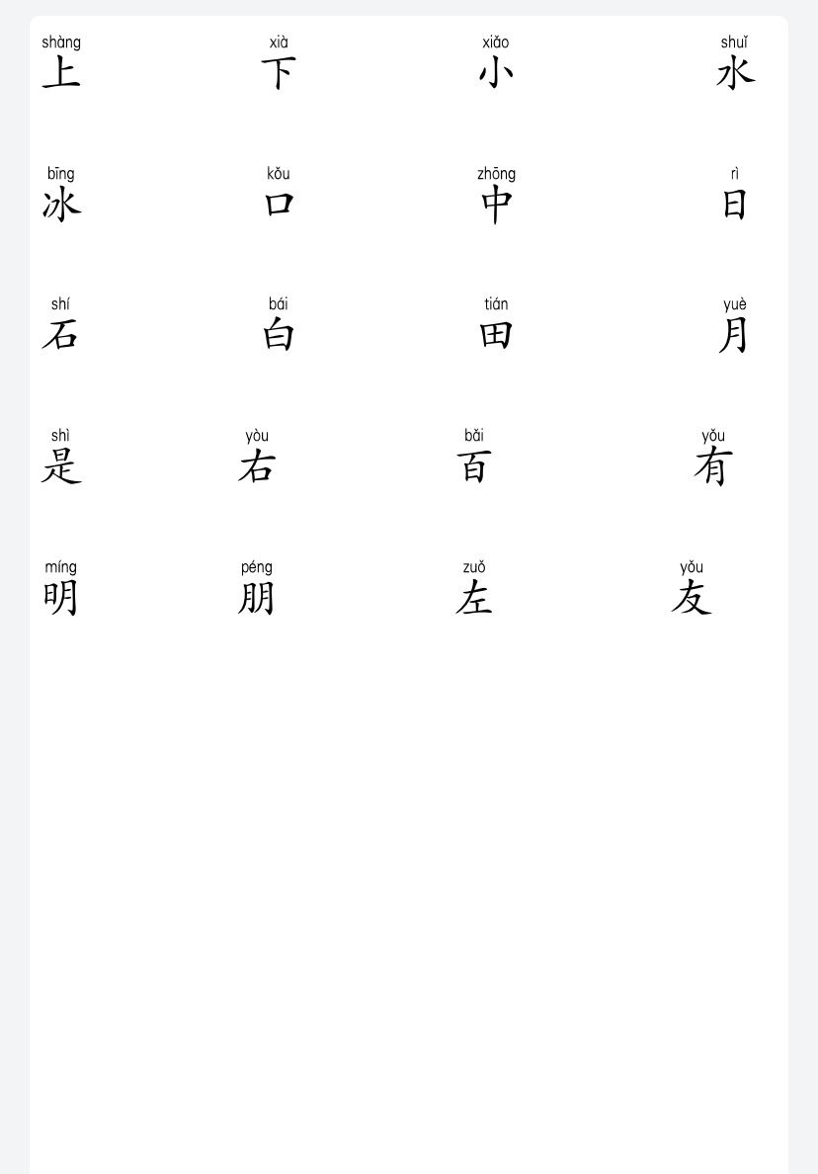 up，go（下down, go）
天上 in the sky, 上工go to work
17.down
上下 up and down，天下the whole world， 上上下下 up and down

18.small（水water）
小人 small person，大小 size，小王 little king，小主人 junior
Master, 太小 too small
19.water (冰 ice)
水火 water & fire， 大水 flood
20. ice
冰水 ice water
21.mouth （中middle）（日day）（石stone, rock）
人口 populations， 口水saliva，大口big mouth，小口 little mouth
22. middle
上中下above middle below，中上 above average，中下below
Average，水中in the water，火中 in the fire
23. day （白white）（田field）（月moon, month）(是 is , am, are, was, were)
一日one day，日中 mid-day ，生日 birthday
24. stone, rock (右right)
大石 big rock，小石 little rock, 火石stone, flint
25. white （百hundred）
白天 day time，白人 Caucasian，白水 plain water， 小白a person’s nickname，白羊 white goat
26. field
水田rice field，下水田down to the rice field，小田 a person’s nickname
27. moon, month（有to have）（明 bright）(朋 friend)
一月 January， 二月February，三月March，大月month with 31 days，小月month with 30 days or less， 一月一日 January 1st ， 二月二日 February 2nd，三月三日 March 3rd
28. is , am, are, was, were
二月是小月 February is a small month
29. right （左 left）（友 friend）
右上 up right， 右下 lower right
30.hundred
一百人one hundred people，一百天 one hundred days，三百人 three hundred people，三白天 three hundred days
31. to have
一月有31 天 January has 31 days，水中有人 There is a man in the water, 田中有水 rice field has water
32. bright
明天 tomorrow, 大明，小明 a person’s nickname
33. friend
34. left
左右 left right，左上 up left，左下 lower left
35. friend
朋友 friend，大朋友 big friend， 小朋友 little friend

每周生字考试:
Week 1: 人，大，火，天，我，你，他，是，的
Week 2: 一，二，三，工，土，王，们，有，要
Week 3: 主，羊， 生，上，下，去，吃，不
Week 4: 小，水，冰，口，日，也，都，和
Week 5: 石，白，田，月，四，五，六，七
Week 6: 百，明，朋，八，九，十，鱼，山
Week 7: 左，友，

